Weapon/Offhand Import (supposing you are using Azerothcore and making a new weapon)

1) Make sure that you have in your DBFilesClient folder the three necessary .csv files (take the ones that are shipped with the module and clean the entries leaving only the headers)
I Generally put them into a loose PATCH-Z.MPQ folder (a folder, not the compressed .mpq)

- Extract your weapon of choice and its textures (I use wow.export for that)
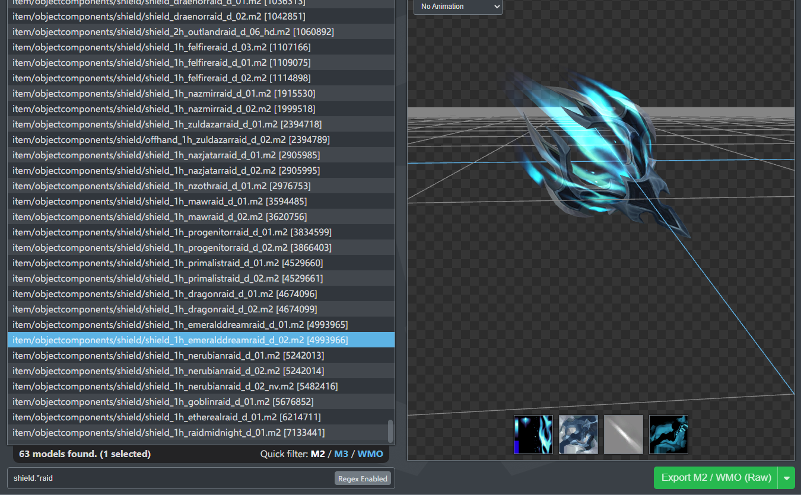
- Make a new entry for your weapon/shield in the Item_Template table of your world database, give it a new ItemDisplayId value (for example Item ID 201010, ItemdisplayID 71028)
- Make a new line in the Item.dbc that mirrors the weapon you just added to the database and give it the same ItemDisplayId value (for example Item ID 201010, ItemdisplayID 71028), I generally copy the line of the base item into a new one and adjust the necessary values.
- Make a new ItemDisplayInfo.dbc line (copy the one of the base item for now) and give it the ID of your item, in Model1 put the model name of your weapon / shield and for good measure pur in Texture 1 the base texture (it will be overwritten by the one in the .csv, but better safe than sorry) and the Icon1 texture. For weapons that's all you need to do in the .dbc
- Copy Item.dbc and ItemDisplayInfo.dbc you just modified into the dbc folder of your server
- Open WXLItemEntryDisplay.csv and add your item line putting ItemID, ItemDisplayID and the folder of the weapon / shield separated by a comma.
Weapon for main hand, offhand and ranged
Shield for shields
Collection when sometimes you get fist weapons turn up in the Collections folder instead of the weapon folder
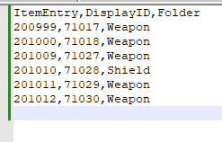
- Open WXLItemDisplayModelMaterials.csv and start adding the lines for the textures
DisplayId, model idex = 0 if it is the only model in Model 1 column, The name of the column where the name of the model is (in yout case ModelName_1), name of the model, Texture Type of the texture you are going to bake (2 is Object_skin, 3 is Weapon_Blade, 4 is Weapon_handle), the folder where the model and textures are (in this case Shield), the name of the texture, SkinMapOnly
Note that if the model is specified in the .dbc, the .dbc will take priority over the .csv
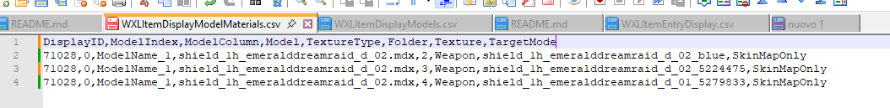
- Remember to put the model and the textures in the right folders in your patch-z.mpq
- Try the model in-game
